Topic: Saving animals

Color scheme: #53bfcb / #1e4e58 / #7da10d / #dcda63 / #213500

#001b4a / #034579 / #008abb / #95cadc / #d4e7ed

#80401b

EQ- How can we create an informational website for society which acknowledges the endangered and stray animals by spreading awareness and encouraging them to help and save the animals from extinction?  
DQ- How can we, Year 8 students create an instructive or informative website that empowers the people in our country to build smart lives by sharing valuable resources and information?

Total pages: 3 landing pages, 1 about us, 1 donation + shop

Home page:

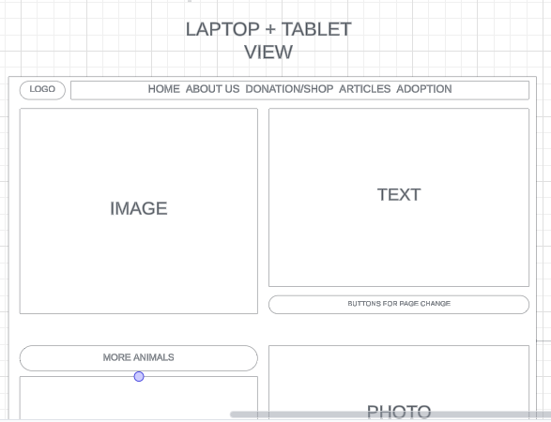

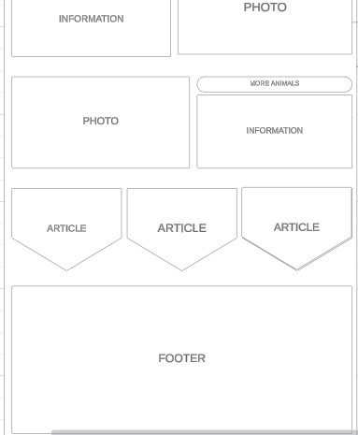

RSP 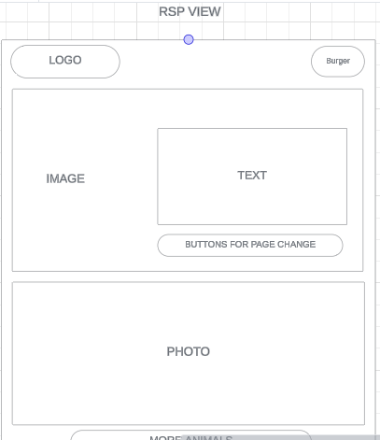

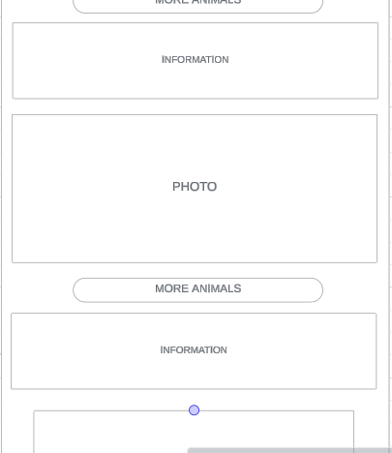

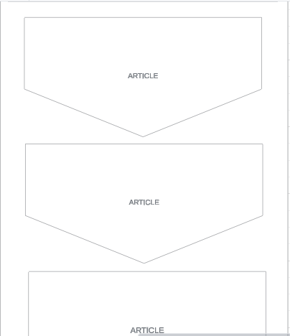

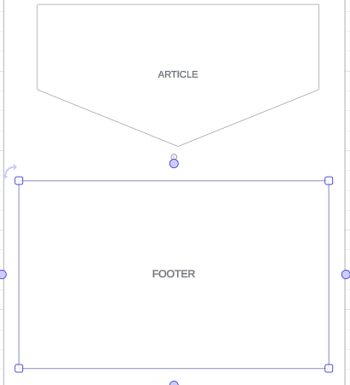

About Us: 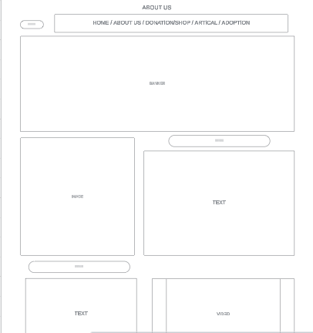

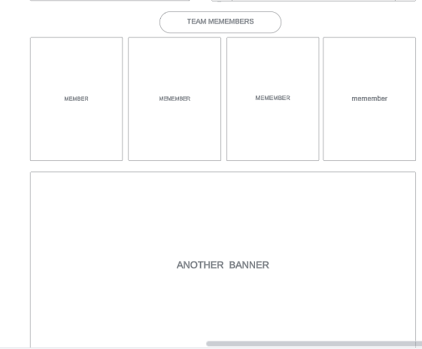

RSP:

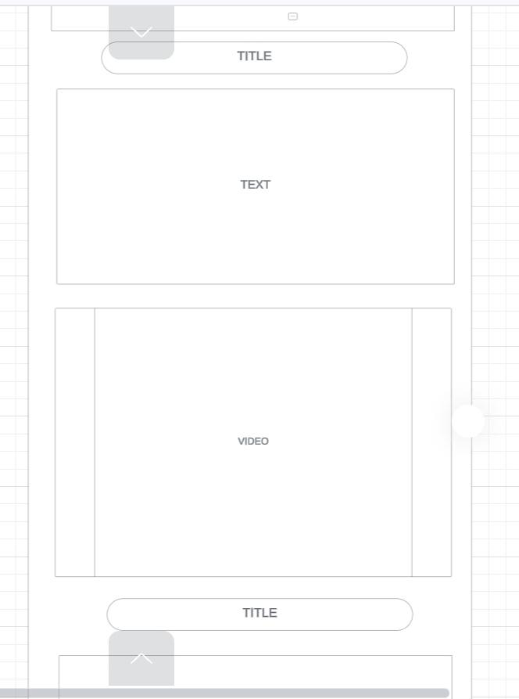

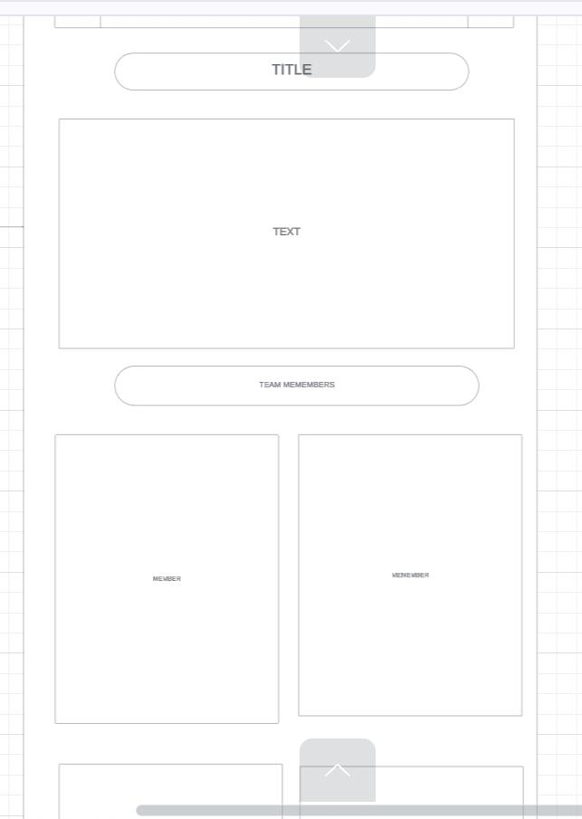

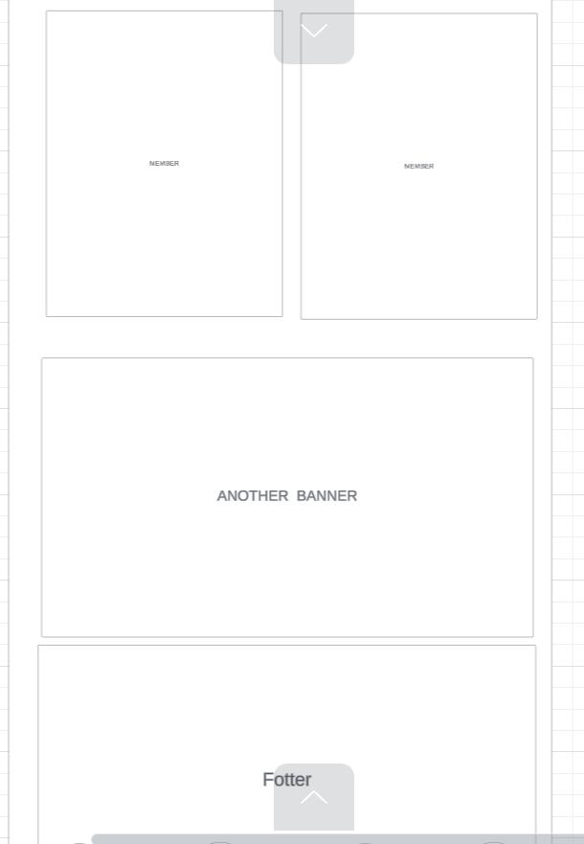

Footer:

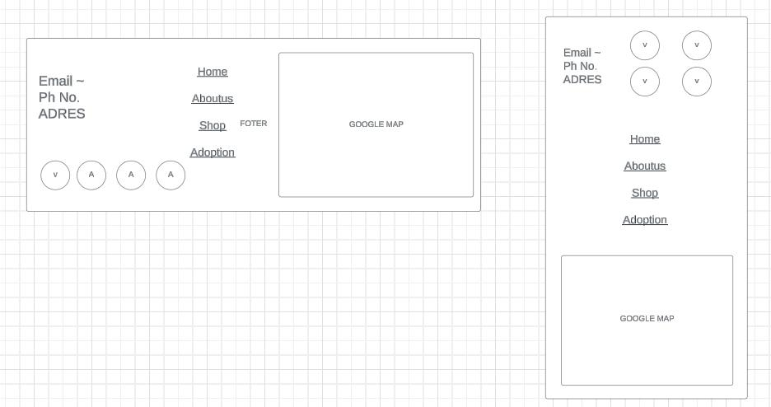

References: